|  |
| --- |
| ORGANIZING MODULES |

When Cobalt generates its modules, they are all placed under the “Default” category on the sidebar menus. This tends to clutter up modules fast if you start working on systems with a large number of modules. Cobalt’s Passport Groups module attempts to put a semblance of organization into our system’s modules by organizing them into “Passport Group Categories”.

**CREATE A NEW PASSPORT GROUP**

Navigate to the “User Passport Group” page on the Admin sidebar and add a new User Passport Group.

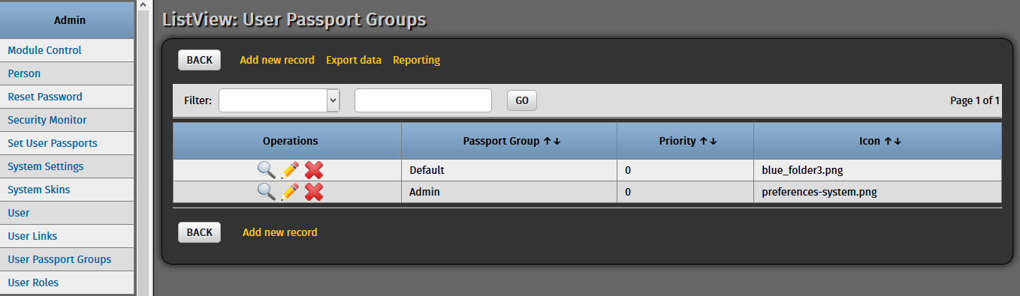

Enter details for our new passport group. Some fields are Cobalt-specific so let us just stick to the default values for now – what matters more is what we would call it.

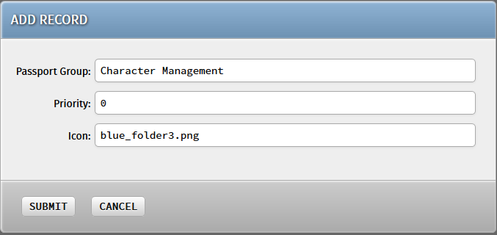

Hit “Submit” and our new User Passport is ready for use!

**MOVE MODULES TO THE NEW USER PASSPORT**

The new User Passport needs “User Links” under it to be visible on the system sidebar. Navigate to the “User Links” page where you will be greeted by a large list of entries.

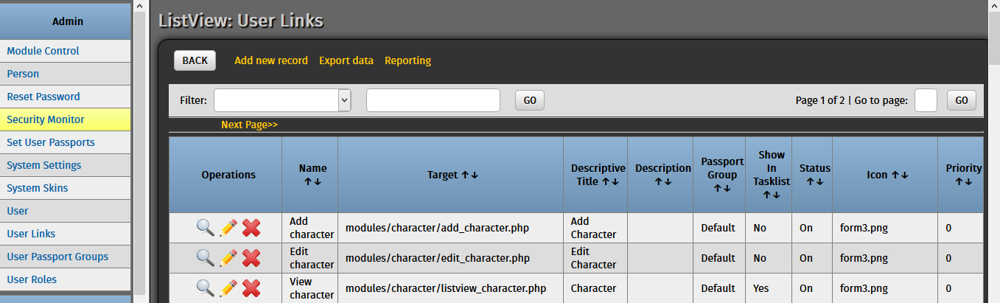

To test our new User Passport in action, move a User Link under that new Passport Group. Click the pencil icon beside the “View Character” User Link to edit its information. Change the value of the “Passport Group” field from “Default” to the new Passport Group we just made.

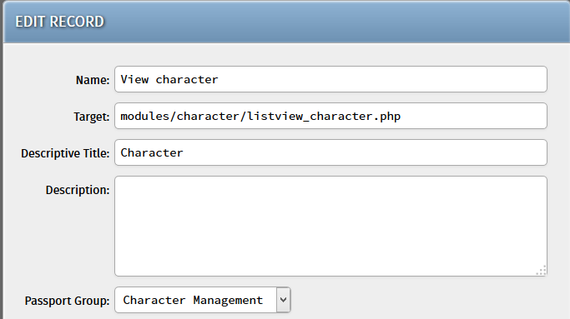

Hit “Submit” and the User Link should now have been moved to the new Passport Group. Refresh the page to update the sidebar information. You should now see a “Character Management” section in the sidebar menus!

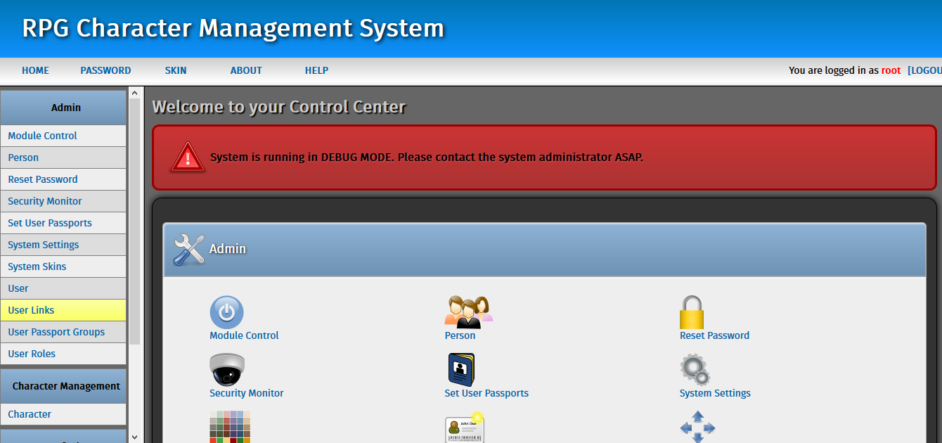

**TRY IT YOURSELF**

Move the other modules (Character Class, Character Skill, Race, Skill, and the remaining modules for Character) into the new User Passport we just created or create new ones for the other module categories. Play around with the User Passports module and organize your Cobalt modules however you like!